**Steps to install Python in Eclipse IDE:**

1. Open Eclipse IDE and click on Help tab:

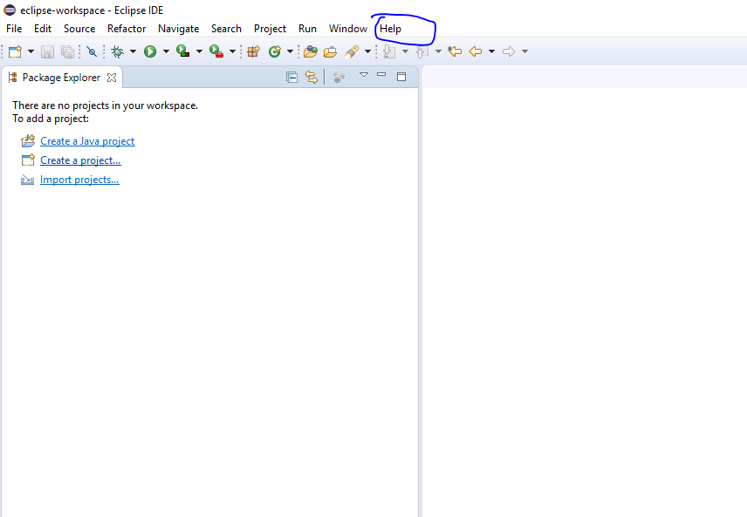

1. Click in install new software.

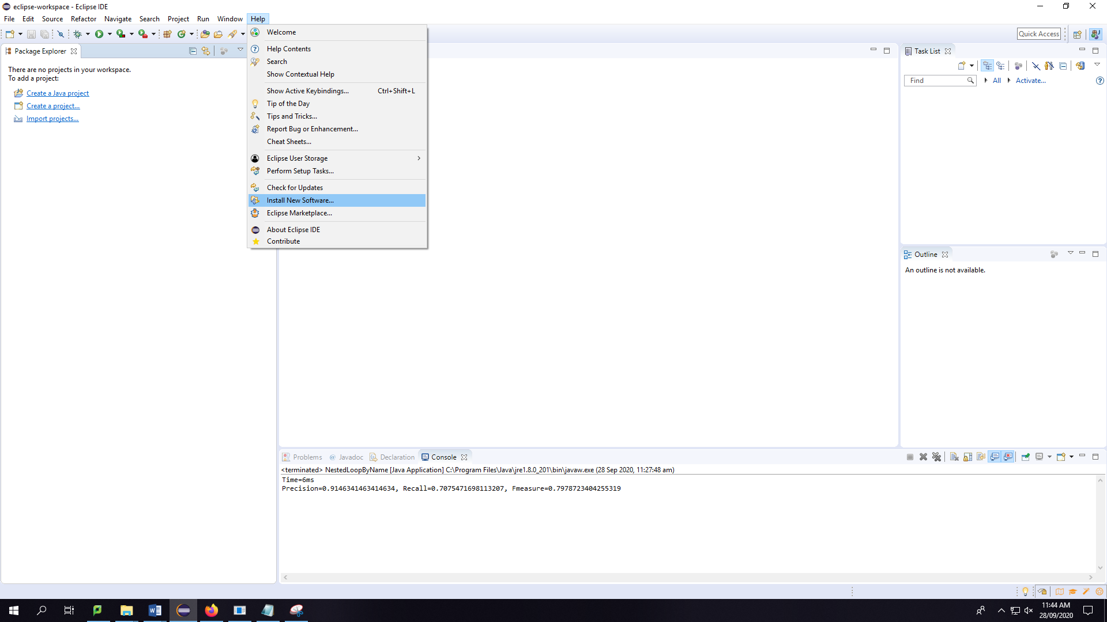

1. In the “work with” section, type: http://pydev.org/updates 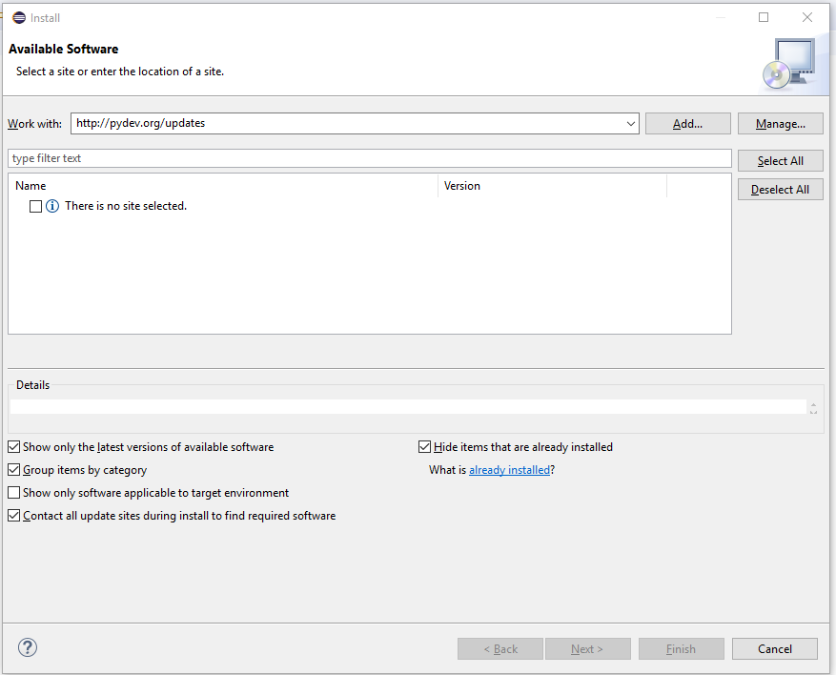

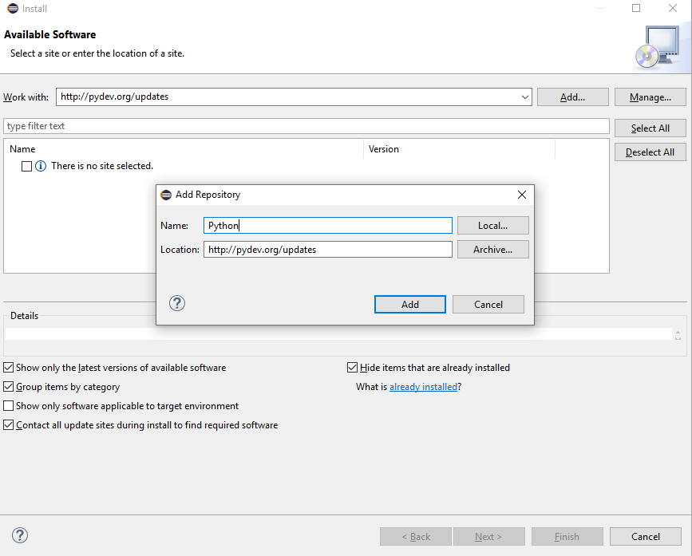

1. After several seconds, two options should appear. Select the PyDev option. **Do not select the "PyDev Mylyn Integration" flag.**

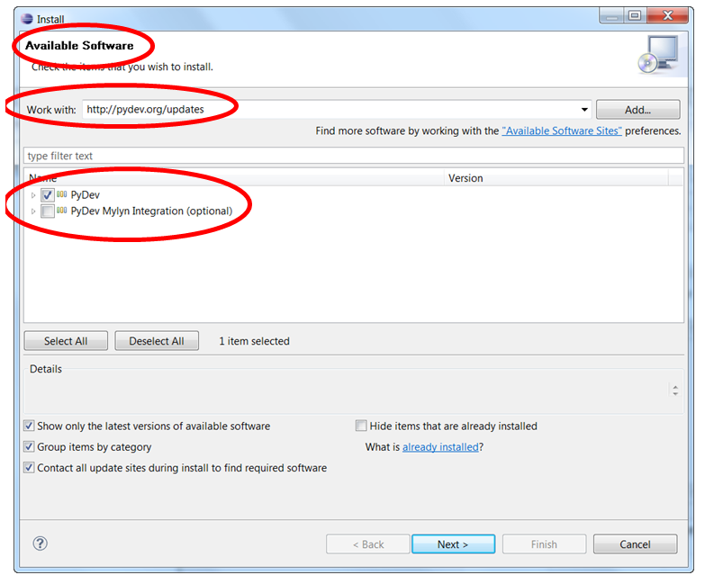

1. Click on next and this window should appear. Click on next.

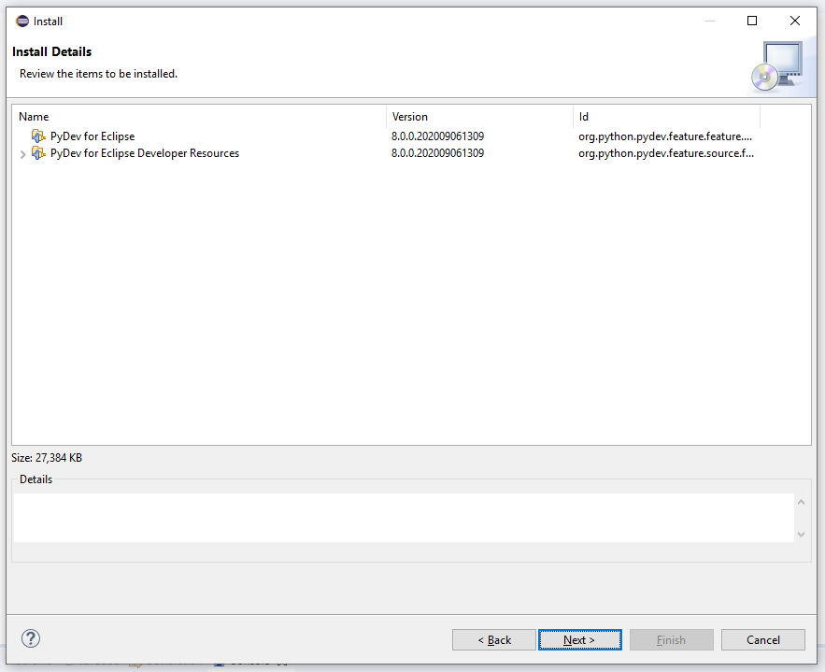

1. Accept the terms and conditions and click on finish.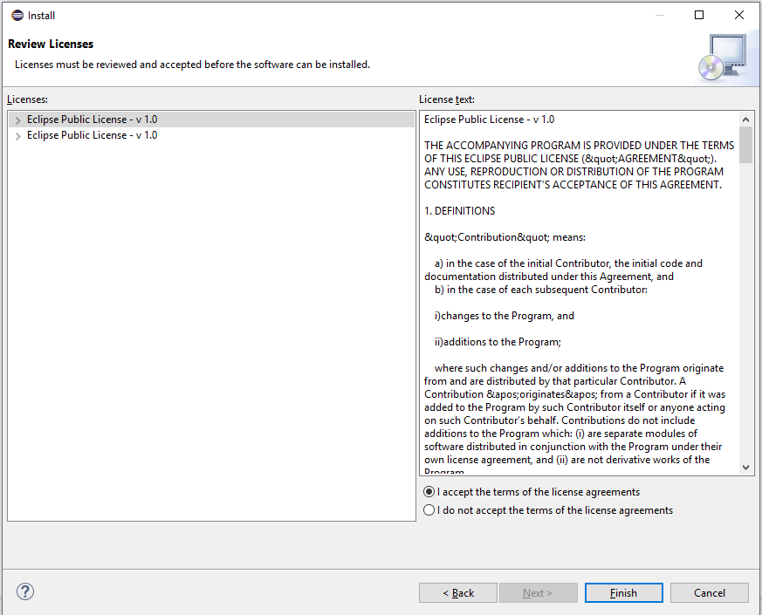
2. After a while, it might show you a security warning. Click on install anyway. 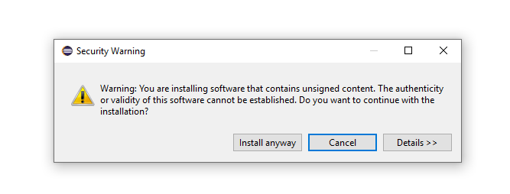
3. Restart the Eclipse IDE by clicking on Restart now option. 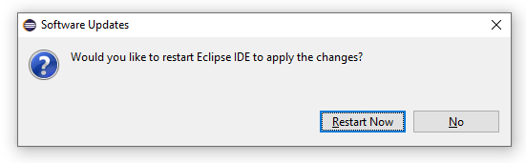
4. Once Eclipse IDE is restarted, Click on workbench icon. 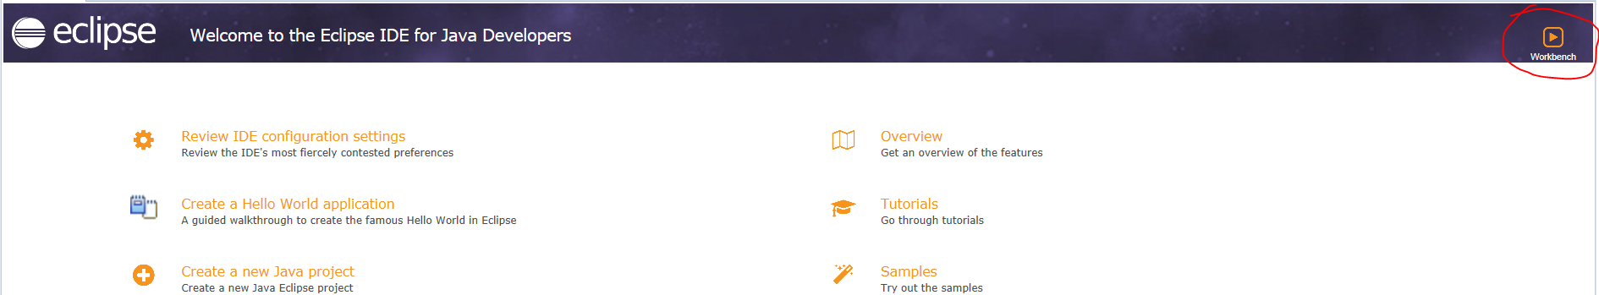
5. Click on “Open perspective” icon on the top right corner. 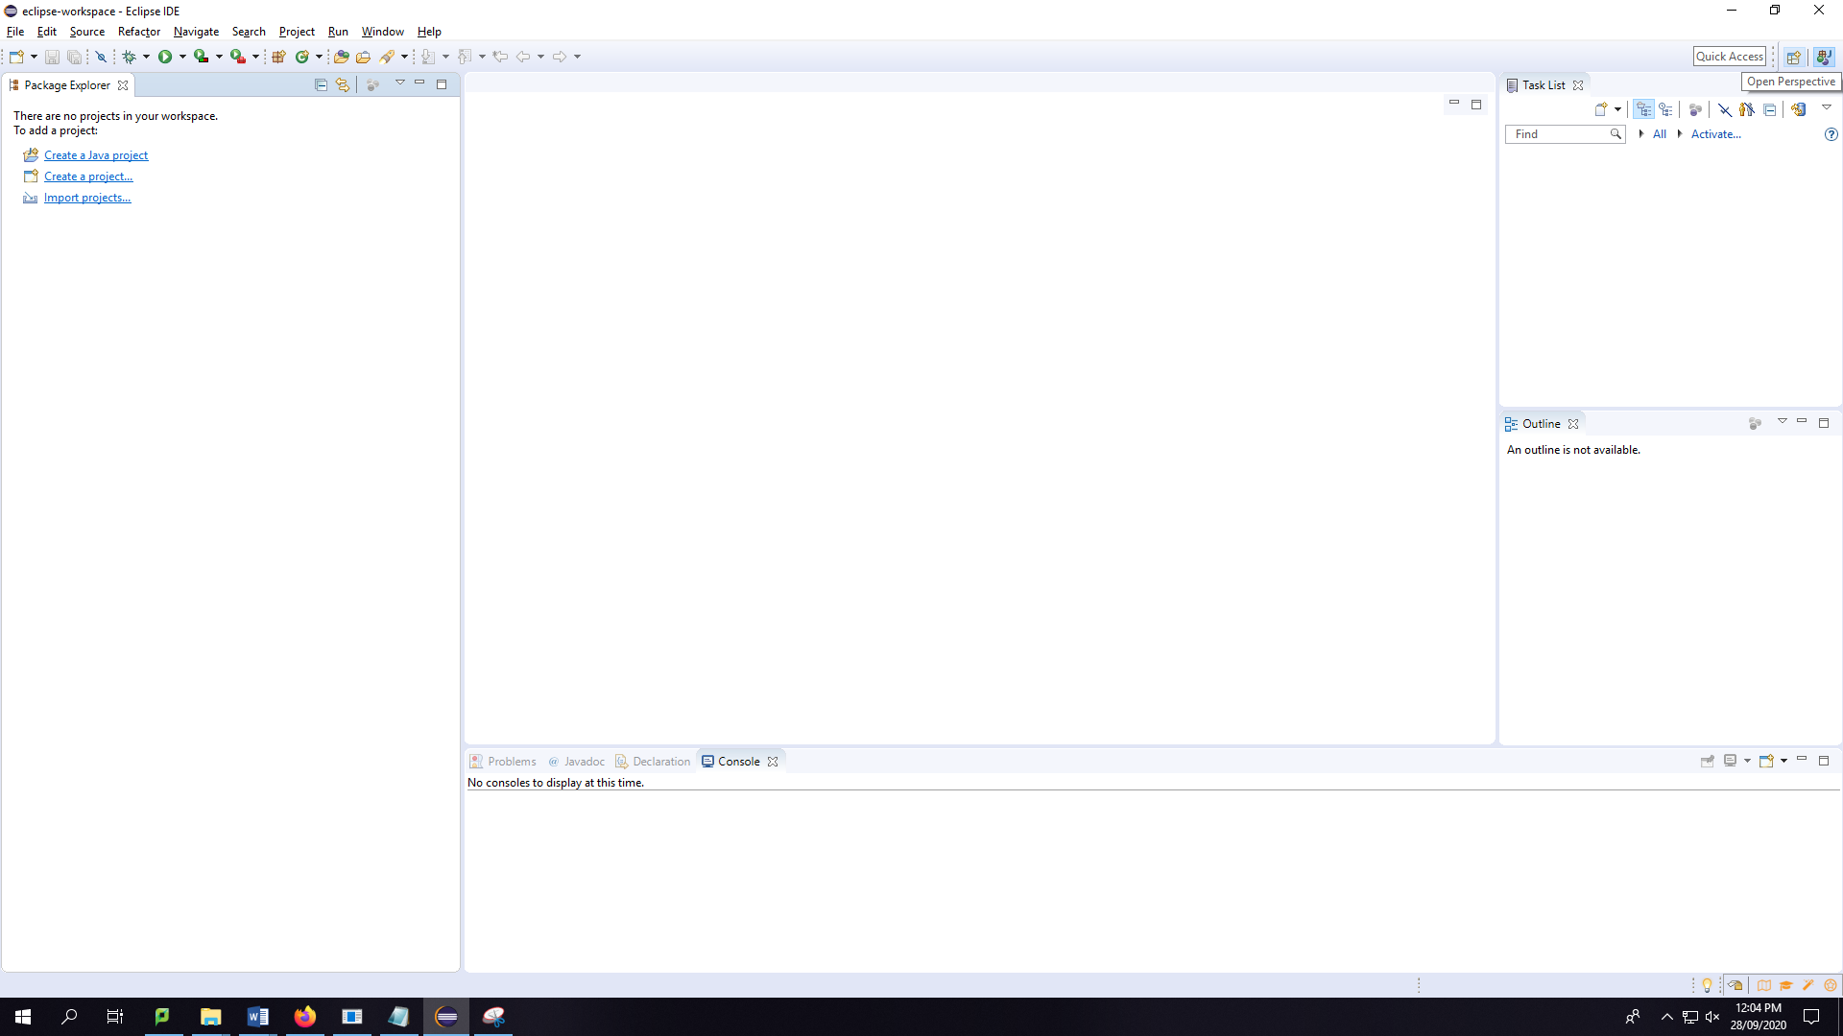
6. Select PyDev option and click Open.

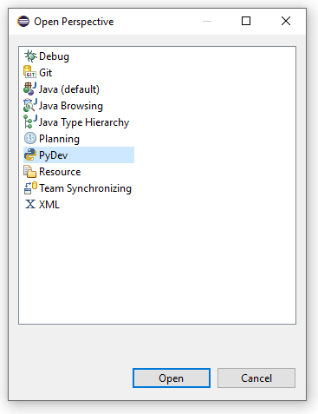

1. Select ‘Import projects from File system’ option in File tab. 
2. Select DataLinkage_py folder and click on Select Folder. 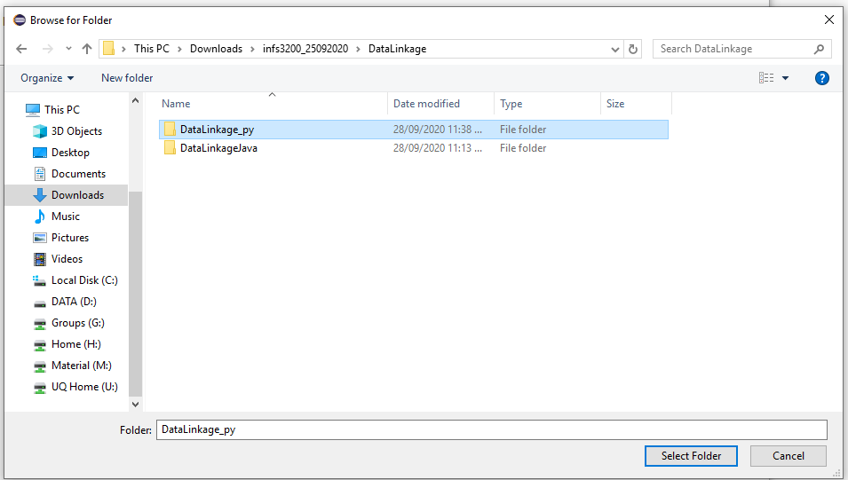
3. Click on Finish. 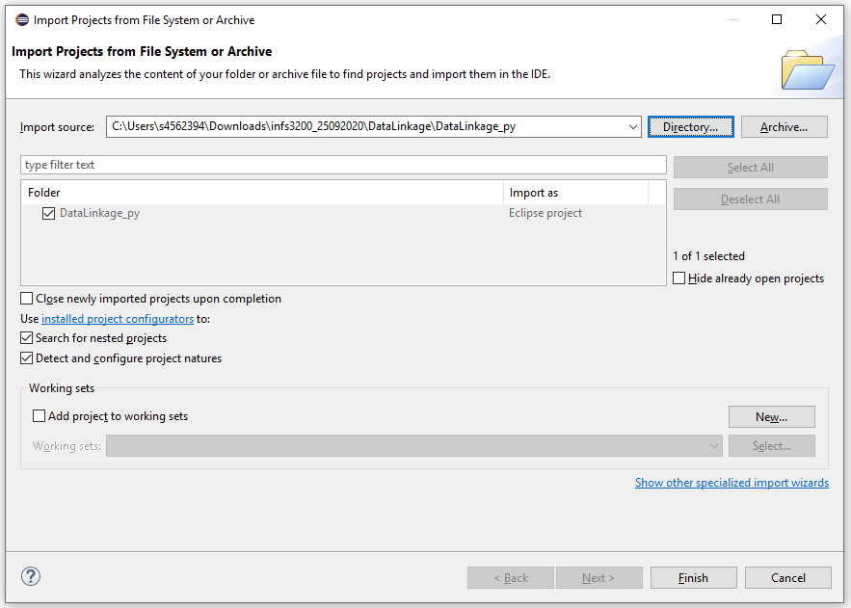

Configure Oracle on Eclipse IDE:

1. Click on Window -> Preferences. 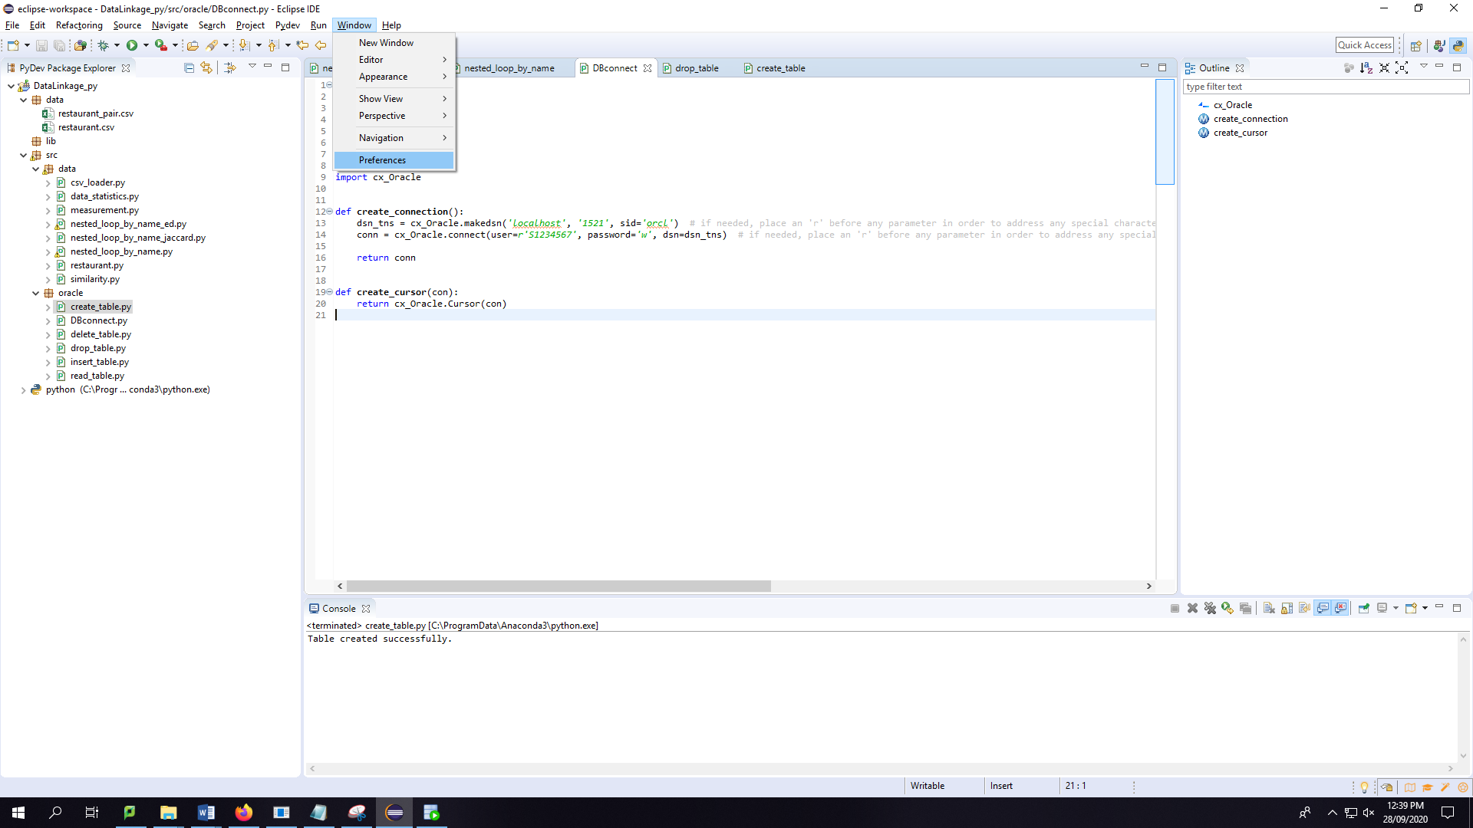
2. Select python Interpreter and click on ‘Manage with Pip’.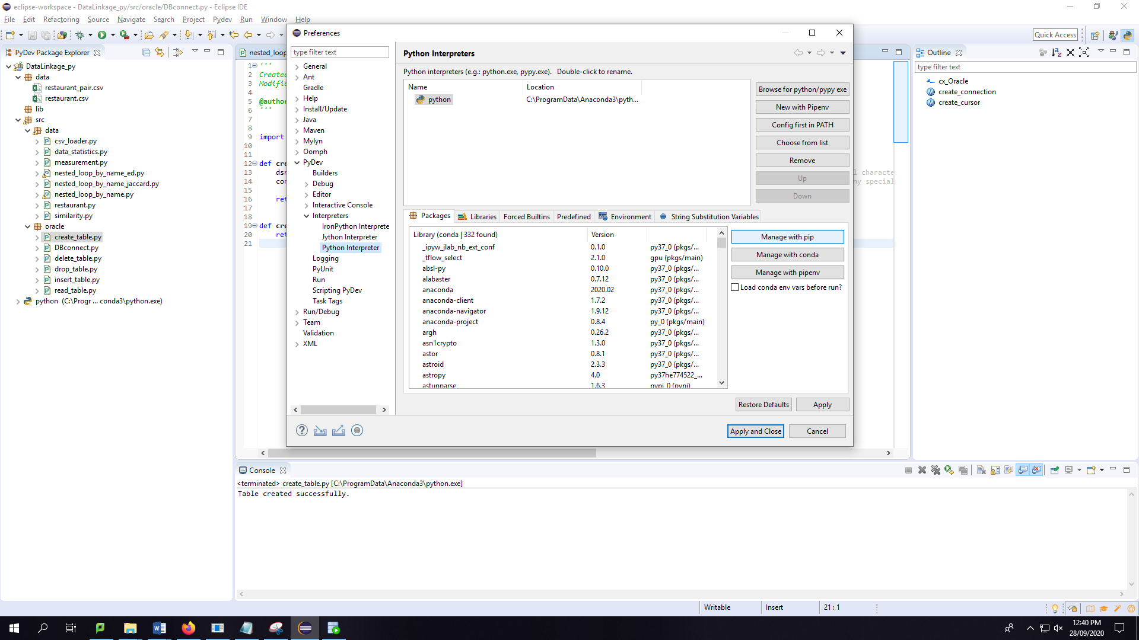
3. Type: install cx_oracle in the command to run panel. Click run.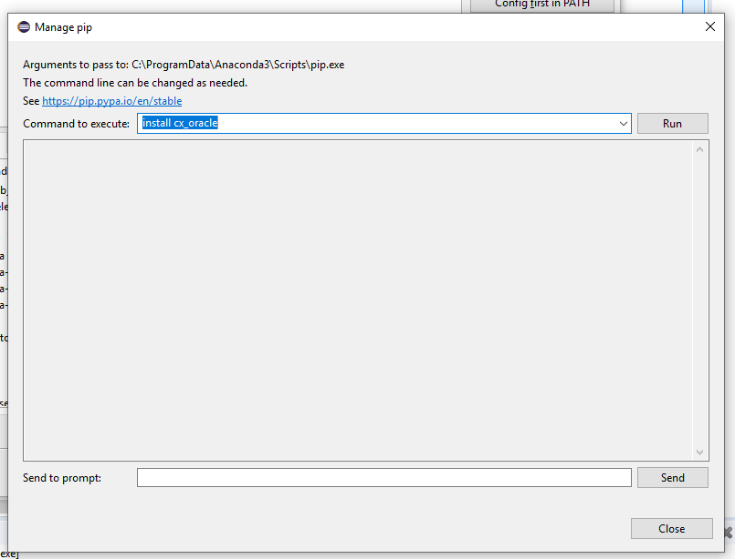
4. Once command is run successfully, click on close and then click on Apply and Close. 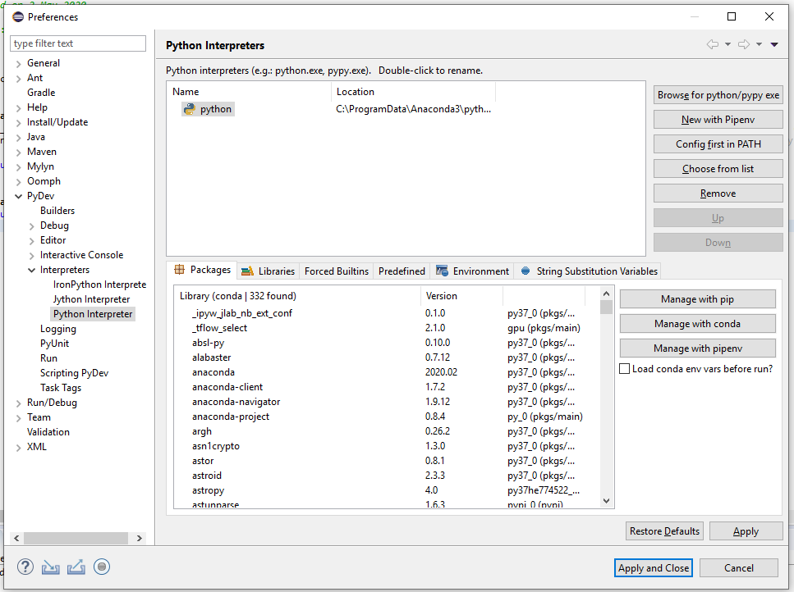

More information on:

<http://mukeshonplsql.blogspot.com/2017/08/installing-python-3-and-eclipse-for.html>

<https://www.rose-hulman.edu/class/csse/resources/Eclipse/eclipse-python-configuration.htm>